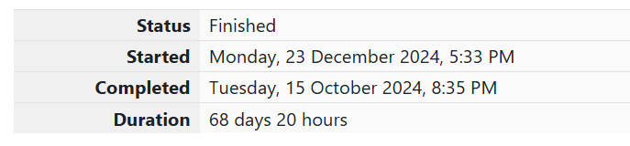

WEEK 01-01 PRACTICE SESSION

1. OBJECTIVE

This is a simple challenge to help you practice printing to stdout. We're starting out by printing the most famous computing phrase of all time! In the editor below, use either printf or cout to print the string Hello, World! to stdout.

CODE

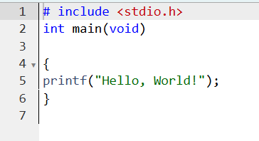

OUTPUT

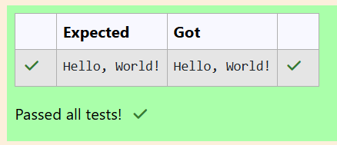

2.OBJECTIVE

This challenge will help you to learn how to take a character, a string and a sentence as input in C. To take a single character ch as input, you can use scanf("%c", &ch); and printf("%c", ch) writes a character specified by the argument char to stdout: char ch; scanf("%c", &ch); printf("%c", ch); This piece of code prints the character ch.

CODE

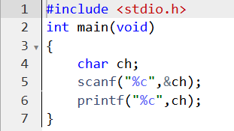

OUTPUT

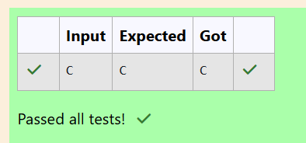

3.OBJECTIVE

Your task is to take two numbers of int data type, two numbers of float data type as input and output their sum: 1. Declare 4 variables: two of type int and two of type float. 2. Read 2 lines of input from stdin (according to the sequence given in the 'Input Format' section below) and initialize your 4 variables. 3. Use the + and - operator to perform the following operations: o Print the sum and difference of two int variable on a new line. return 0; } 6 7 3 o Print the sum and difference of two float variable rounded to one decimal place on a new line.

CODE

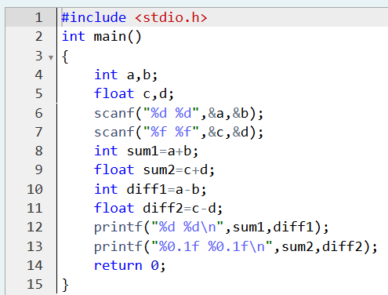

OUTPUT

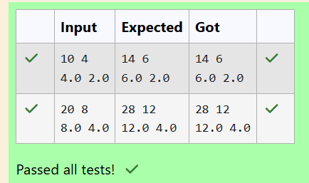

WEEK 01-02 PRACTICE SESSION

1.OBJECTIVE

Write a program to input a name (as a single character) and marks of three tests as m1, m2, and m3 of a student considering all the three marks have been given in integer format. Now, you need to calculate the average of the given marks and print it along with the name as mentioned in the output format section. All the test marks are in integers and hence calculate the average in integer as well. That is, you need to print the integer part of the average only and neglect the decimal part

Code

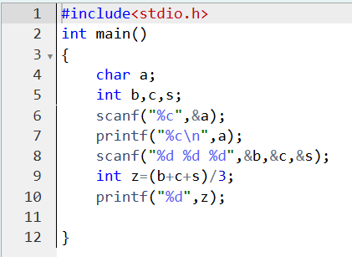

OUTPUT

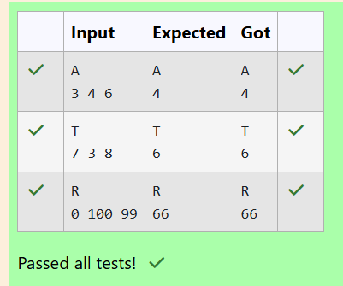

2.OBJECTIVE

Input consists of the following space-separated values: int, long, char, float, and double, respectively.

CODE

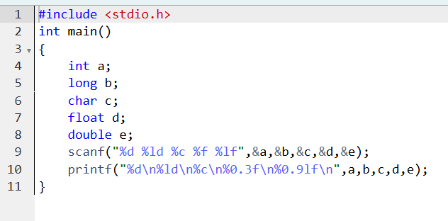

OUPUT

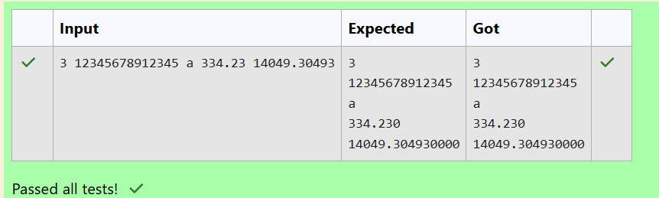

3.OBJECTIVE

Write a program to print the ASCII value and the two adjacent characters of the given character.

CODE

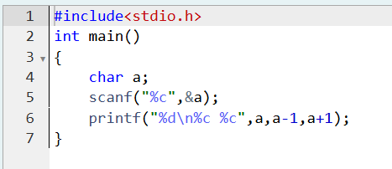

OUTPUT

